Scheduled Message Sending
Requirements and
Functional Specification

Owner: | Anthony Alexander
Created: | 07 Sep 1999
Last Reviewed: | 16 Nov 1999
Revision: | 0.05
Status: | Draft
Contributors: | Keith de Mendonca  Kevin Dixon  Gregory Lavery
Distribution: | Keith de Mendonca  Kevin Dixon  Peter Harper  Gregory Lavery
Network Location: | \\symbian-epoc1\psisoft\c&i\Messaging\GT messaging 5.2\Documents\SCHSEND Functional Spec.doc
Perforce Location: | \\EPOC\main\generic\msg\schsend\docs\Documents\SCHSEND Functional Spec.doc

1. Introduction
1.1 Purpose and Scope
1.2 References
2. Requirements
2.1 Overview
2.2 New Data Requirements
3. Functional Specification
3.1 Overview
3.2 Class Diagrams
3.3 TMsvEntry
3.4 CScheduleBaseServerMtm
3.5 CMsvScheduledSend
3.6 CMsvScheduleSettings
3.7 TMsvEntryScheduleData
3.8 TMsvOffPeakTime
3.9 CMsvOffPeakTimes
3.10 TMsvSendErrorAction
3.11 CMsvSendErrorActions
3.12 CMsvScheduledEntry
4. SCHEXE.EXE

Introduction

Purpose and Scope
There is a new requirement that the messaging applications support scheduled sending. At this moment only the SMS and Fax MTMs are required to support scheduled sending. This document proposes changes to the messaging architecture that will enable scheduled sending of messages.

This document will continue to be revised until a definitive design is determined.

References
 | Document | Date | Rev. | Author/Owner
1. | Task Scheduler Design | 14/6/1999 | 0.07 | Martin Armstrong
2. | Linda PDA SW Fax UI Specification | 26/5/1999 | 2.1 | Harri Räisänen (see Kevin Dixon)
3. | User Documentation for Task Scheduler | 23/61999 | 0.02 | William Bamberg
4. | Task Scheduler Class Diagram |  |  | g:\schsvr\design\model.mdl
5. | System Agent Specification | 12/7/1999 | 0.04 | Martin Armstrong

Requirements

Overview
This section describes the new functionality of the messaging architecture needed to support message scheduling.

To summarise, the messaging architecture needs to be able to:

- Schedule a message on the task scheduler.
- Delete (un-schedule) a message’s entry on the task scheduler.
- (Automatically) Re-schedule a message on the task scheduler if it fails an attempt at sending.

An associated requirement is that the messaging architecture provide meaningful status/state information, such as whether a message is currently scheduled, re-scheduled, sending, failed etc.

New Data Requirements
The following data needs to be stored for each message in order to support scheduling.

Minimum Data Requirements
Data | Description | Default | Range | Bits
TaskID | The task id allocated by the task scheduler for the message. | 0 | TInt | 32
OffPeak Flag | Whether the message is to be sent off-peak. | EFalse | EFalse or ETrue | 1
AttemptCount | The number of times the server has tried to send the message. | 0 | 0 to max(TInt) | 32
Time | The time the message has been scheduled. (Can be stored in the iDate member of TMsvEntry) |  | TTime | 64
Scheduled Flag | Specifies that the message was originally scheduled. Therefore the Time, AttemptCount and TaskID are reliable. | EFalse | EFalse or ETrue | 1
Sending State | See document “Sending States” | 0 |  | 4?

Desirable Data Requirements
Data | Description | Default | Range | Bits
ScheduleID | The ID of the schedule on which the message (task) has been scheduled. | 0 | TInt | 32

Functional Specification

Overview
Scheduled message sending will be implemented in the following way:

- Use the CBaseServerMTM::StartCommandL function to handle all scheduling. New cases will need to be added to the StartCommandL function in each MTM that handles scheduling. These cases will allow:
- Scheduling messages
- Deleting the schedule for messages
- Re-Scheduling messages
- Sending scheduled messages (to be called by the <Send>.EXE).
- Checking the schedule of a message against the task scheduler.

- Create a CMsvScheduledSend class which encapsulates all scheduling requirements. The server MTMs can use this class to perform all scheduling.

- Add a new Capability of the MTMs to determine whether an MTM supports scheduling.

- Modify TMsvEntry to store the data required to support scheduled sending.

Class Diagrams

Scheduling Classes
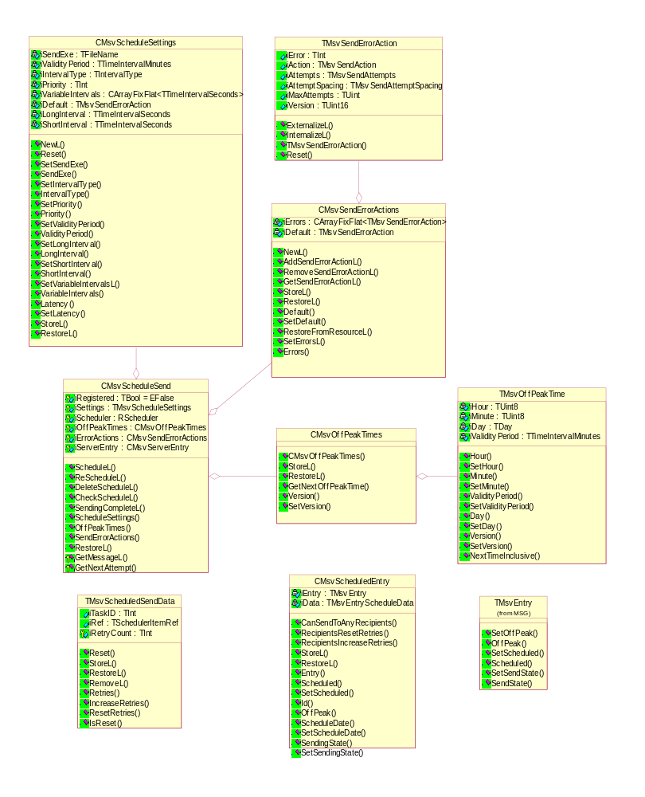

Fax Specific
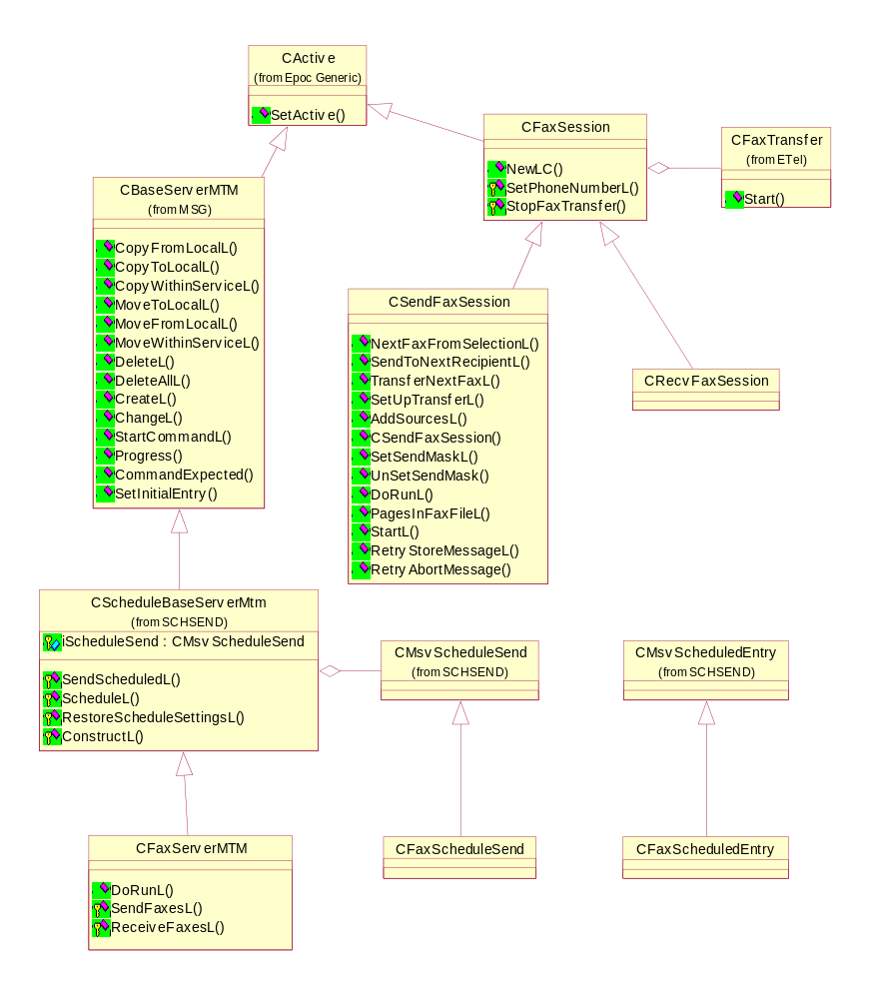

TMsvEntry

Overview
Changes are required to TMsvEntry to support scheduled sending. This section describes these changes.

See also section 2.2, which outlines the data that needs to be stored with a message in order to support scheduled sending.

New Data

In the TMsvEntry
Data | Store in data member | Value | Mask | Bits
Time | iDate |  |  | 64
OffPeak Flag | iData | 0x00000004 |  | 1
Scheduled Flag | iData | 0x00000800 |  | 1
Sending State | iData |  | 0x00F00000 | 4

In a stream associated with the TMsvEntry
The additional data about a message’s schedule will be stored in a stream associated with the TMsvEntry:

Data | Default | Class
TaskID | 0 | TInt
AttemptCount | 0 | TInt
ScheduleID | 0 | TSchedulerItemRef

This will be encapsulated in the new class TMsvEntryScheduleData outlined in Section 5.

New Functions
The following functions need to be implemented in TMsvEntry to get and set the new data.

OffPeak Flag
TBool OffPeak()
{
Returns the OffPeak flag.
}

void SetOffPeak(TBool aOffPeak)
{
Sets the Off-peak flag.
}

Scheduled Flag
TBool Scheduled()
{
Returns the Scheduled flag.
}

void Scheduled(TBool aScheduled)
{
Sets the Scheduled flag.
}

Sending State
TInt SendingState()
{
Returns the Sending State.
}

void SetSendingState(TInt aSendingState)
{
Sets the Sending State if valid. aSendingState must be in the range 0x00 to 0x0F.
}

Class Diagram
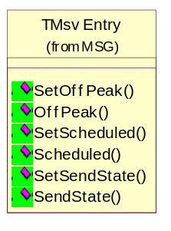

CScheduleBaseServerMtm

Overview
All Server MTMs that support scheduling should derive from this class.

It contains three pure virtual functions which must be implemented by the Server MTM. These functions are not required for interoperability with any other classes, however they are essential functionality that must be implemented by a Server MTM that support scheduling.

Implementation
Library | schsend.lib
DLL | schsend.dll
Header | ScheduleBaseServerMtm.h

Derivation
Derives from CBaseServerMtm.

Class Diagram
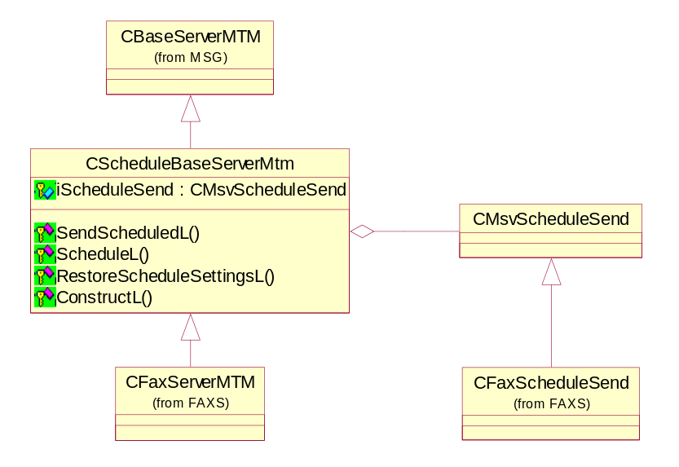

ScheduleL()
virtual void ScheduleL(CMsvEntrySelection& aSelection, const TBool aMove, const TDesC8& aParameter, TRequestStatus& aStatus) = 0;

Description
This is a pure virtual function which must be implemented by the Server MTM. It should schedule a message using iScheduleSend.ScheduleL(). Make sure RestoreScheduleSettingsL() is called before iScheduleSend.ScheduleL().

Arguments
CMsvEntrySelection& aSelection | The selection of messages that need to be scheduled.
const TBool aMove | Whether to perform a Move (ETrue) or a Copy (EFalse) when sending has completed.
const TDesC8& aParameter | The parameter that is required when sending the messages.
TRequestStatus& aStatus

Fax Implementation (as at 17/11/1999)
void CFaxServerMtm::ScheduleL(CMsvEntrySelection& aSelection, const TBool aMove, const TDesC8& aParameter, TRequestStatus& aStatus)
{
TInt cmdId = (aMove ? KFaxMTMSendScheduledMove : KFaxMTMSendScheduledCopy);

iScheduleSend->ScheduleL(aSelection, cmdId, aParameter);

aStatus = KRequestPending;
iReport = &aStatus;
User::RequestComplete(iReport, KErrNone);
}

SendScheduledL()
virtual void SendScheduledL(CMsvEntrySelection& aSelection, const TBool aMove, const TDesC8& aParameter, TRequestStatus& aStatus);

Description
Sends messages that were previously scheduled.

Arguments
CMsvEntrySelection& aSelection | The selection of messages that were previously scheduled and now need to be sent.
const TBool aMove | Whether to perform a Move (ETrue) or a Copy (EFalse) when sending has completed.
const TDesC8& aParameter | The parameter that is required when sending the messages.
TRequestStatus& aStatus

Implementation (as at 17/11/1999)
void CScheduleBaseServerMtm::SendScheduledL(CMsvEntrySelection& aSelection, const TBool aMove, const TDesC8& /*aParameter*/, TRequestStatus& aStatus)
{
if (aMove)
{
MoveFromLocalL(aSelection, NULL, aStatus);
}
else
{
CopyFromLocalL(aSelection, NULL, aStatus);
}
}

RestoreScheduleSettingsL()
virtual void RestoreScheduleSettingsL() = 0;

Description
This is a pure virtual function which must be implemented by the Server MTM. It should restore all the schedule settings either from a file store or a resource file.

Fax Implementation (as at 17/11/1999)
void CFaxServerMtm::RestoreScheduleSettingsL()
{
__ASSERT_DEBUG(iServerEntry->Entry().iType==KUidMsvServiceEntry, gPanic(EFaxsServerEntryNotAService1));

CMsvStore* store = iServerEntry->ReadStoreL();

CleanupStack::PushL(store);
iScheduleSend->RestoreL(*store);
CleanupStack::PopAndDestroy(); //store

//Restore the errors from a resource file
TResourceReader reader;
HBufC8* rBuf = iResourceFile.AllocReadLC(ERROR_ACTIONS);
reader.SetBuffer(rBuf);
iScheduleSend->SendErrorActions().RestoreFromResourceL(reader);

CleanupStack::PopAndDestroy(); //rBuf
}

ConstructL()
virtual void ConstructL() = 0;

Description
This is a pure virtual function which must be implemented by the Server MTM. It should construct the iScheduleSend member.

Note: iScheduleSend must by destroyed in the Server MTM (derived) class.

CMsvScheduledSend

Overview
CMsvScheduledSend implement all the message scheduling in one class. This class can be used by the Server MTMs to scheduled messages on the Task Scheduler.

It also manages re-scheduling messages when particular errors occur, and scheduling messages to send off-peak.

Implementation
Library | schsend.lib
DLL | schsend.dll
Header | MsvScheduleSend.h

Derivation
Derives from CBase.

Class Diagram
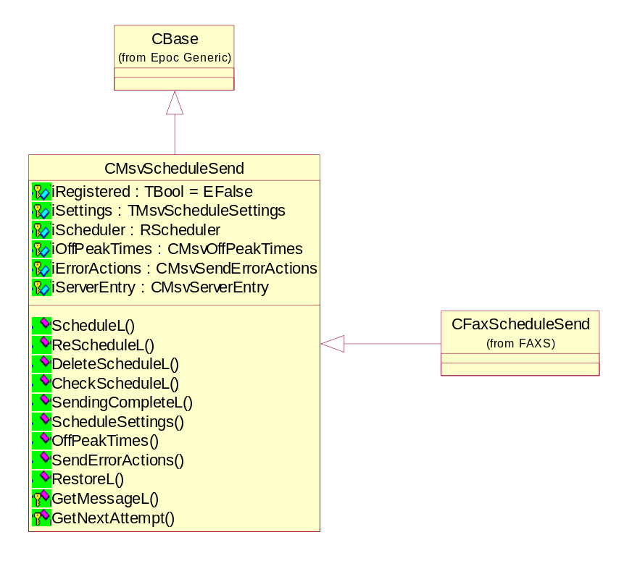

Protected Data Members
TBool iRegistered | Whether this has been registered with the Task Scheduler. Initially set to EFalse.
CMsvScheduleSettings iSettings | The Server MTM specific scheduled message sending settings.
RScheduler iScheduler | Provides an interface to the Task Scheduler.
CMsvOffPeakTimes iOffPeakTimes | The Server MTM specific off peak time periods.
CMsvSendErrorActions iErrorActions | The Server MTM specific actions to take when particular errors occur during message sending.

NewL()
static CMsvScheduledSend* NewL(CMsvServerEntry& aServerEntry);

Description
CMsvScheduledSend factory function:

- Constructs a CMsvScheduledSend object.
- Calls the private function ConstructL.
- Returns the new CMsvScheduledSend object.

Arguments
CMsvServerEntry& aServerEntry | The CMsvServerEntry of the server MTM of which this CMsvScheduledSend object is a member.

ScheduleL()
void ScheduleL(const CMsvEntrySelection& aEntries, const TInt aCommandId, const TDesC8& aParameter);

Description
Schedules messages on the task scheduler.

Pseudo Code
- If the messages have already been schedule, then delete the schedule.

- Schedule the messages on the task scheduler. If the messages are to be sent Off-peak only, then make sure the messages are scheduled within the system’s Off-peak times.
- Update each message’s schedule data.
- Set each message’s send state to SCHEDULED.

If there is an error then leave with a meaningful error message.

Arguments
const CMsvEntrySelection& aEntries | Array of message Ids that need to be scheduled. This array cannot be empty. All the messages identified in aEntries must:  - Belong to the same MTM.  - Are to be scheduled for the same time  - Have the same setting for their OffPeak() flag.  - The time they are to be scheduled is stored in the iDate member of their corresponding TMsvEntry.
- const TInt aCommandId | The Command ID that will be passed to CMsvSession::TransferCommandL() when it is time to send the messages.
const TDesC8& aParameter | Server MTM specific binary data that will be passed to CMsvSession::TransferCommandL() when it is time to send the messages. Note: Maximum size is 512 bytes.

DeleteScheduleL()
void DeleteScheduleL(const CMsvEntrySelection& aEntries);

Description
To delete the schedule for a message from the task scheduler. Does not delete the message.

Pseudo Code
For each message that had previously been scheduled:

- Delete the task from the task scheduler
- Delete the schedule data (see section 5).
- Set the sending state to KMsvSendStateUnknown.

Arguments
const CMsvEntrySelection& aEntries | Array of message Ids that need to be deleted from the task scheduler. This array cannot be empty. All the messages identified in aEntries must belong to the same MTM. It is not a precondition that each message had already been scheduled on the task scheduler.

ReScheduleL()
void ReScheduleL(const CMsvEntrySelection& aEntries, const TInt aCommandId, const TDesC8& aParameter);

void ReScheduleL(const CMsvEntrySelection& aEntries, const TInt aCommandId, const TDesC8& aParameter, const TMsvSendErrorAction& aSendErrorAction);

Description
Determines when the messages should be re-scheduled on the task scheduler, then schedules the messages at the new time(s).

Pseudo-code
- Determine when the messages should be re-sent by calling GetNextAttempt on iSendErrorActions.

- Note: If the first message in aEntries has the OffPeak() flag set to ETrue then the messages will be re-scheduled in during the Server MTM’s off-peak times.

- Schedule the messages on the task scheduler (as ScheduleL above).

- If successful, update each message’s send state to RESEND.

Arguments
const CMsvEntrySelection& aEntries | Array of message Ids that need to be re-scheduled. This array cannot be empty. All the messages identified in aEntries must belong to the same MTM. It is not a precondition that each message has already been scheduled on the task scheduler.
const TInt aCommandId | The Command ID that will be passed to CMsvSession::TransferCommandL() when it is time to send the messages.
const TDesC8& aParameter | Server MTM specific binary data that will be passed to CMsvSession::TransferCommandL() when it is time to send the messages. Note: Maximum size is 512 bytes.
const TMsvSendErrorAction& aErrorAction | The specific action to take with the messages. If this argument is omitted then ReScheduleL() used the iError member of each TMsvEntry to find the related TMsvSendErrorAction in iErrorActions.

CheckScheduleL()
void CheckScheduleL(const CMsvEntrySelection& aEntries);

Description
Verifies that the schedule information stored in the message is the same as that on the task scheduler.

Pseudo-code
For each message in aEntries:

- Check that the message has been scheduled on the task scheduler.
- If so, then update the schedule data in TMsvEntry and TMsvEntryScheduleData with what is stored on the task scheduler. Make sure the message’s send state is SCHEDULED or RESEND. Make sure the message’s scheduled flag is ETrue.
- If not, then set the message’s send state to WAITING or FAILED. Set the message’s scheduled flag to EFalse.

Arguments
const CMsvEntrySelection& aEntries | Array of message Ids that need to be checked against the task scheduler. This array cannot be empty. All the messages identified in aEntries must belong to the same MTM. It is not a precondition that each message has already been scheduled on the task scheduler.

SendingCompleteL()
void SendingCompleteL(const CMsvEntrySelection& aEntries);

void SendingCompleteL(TMsvEntry& aEntry, const TBool aChangeEntry = ETrue);

Description
When a message that had previously been scheduled is either sent or has failed then SendingCompleteL must be called. This function:

- Deletes the TMsvEntryScheduleData associated with the message.
- Sets the Scheduled flag to EFalse.
- If required, calls ChangeEntry on the message server entry.

Note: SendingCompleteL does not:

- Change the sending state of each message; nor
- Delete each message from the task scheduler.

Arguments
const TMsvEntrySelection& aEntries | Array of message Ids. This array cannot be empty. All the messages identified in aEntries must belong to the same MTM. It is not a precondition that each message has already been scheduled on the task scheduler.
TMsvEntry& aEntry | The message which was either successfully sent or which failed (all the attempts) to send. It is not a precondition that the message has already been scheduled on the task scheduler.
const TBool aChangeEntry | If aChangeEntry is ETrue then SendingCompleteL will call CMsvServerEntry::ChangeEntry to update the message on the message server. Default is ETrue.

Settings()
CMsvScheduleSettings& Settings();

Description
Returns a reference to the iSettings member.

Arguments
None.

Returns
Reference to the iSettings member.

OffPeakTimes()
CMsvOffPeakTimes& OffPeakTimes();

Description
Returns a reference to the iOffPeakTimes member.

Arguments
None.

Returns
Reference to the iOffPeakTimes member.

SendErrorActions()
CMsvSendErrorActions& SendErrorActions();

Description
Returns a reference to the iSendErrorActions member.

Arguments
None.

Returns
Reference to the iSendErrorActions member

RestoreL
void RestoreL(CMsvStore& aStore);

Description
Calls the RestoreL function of:

- iSettings
- iOffPeakTimes
- iSendErrorActions

Each of these members are restored from separate streams in aStore. If the Server MTM stores any of these members in a different store or resource file then RestoreL may need to be overwritten in the base class.

Arguments
CMsvStore& aStore | Each of the data members will be restored from separate streams of aStore.

GetMessageL()
virtual CMsvScheduledEntry* GetMessageL(const TMsvId aId) const = 0;

Description
Returns a pointer to an object of a class derived from CMsvScheduledEntry, which encapsulates the schedule (and recipient) information related to the message identified by aId.

This is a pure virtual function, therefore must be implemented in a derived class of CMsvScheduleSend.

It is expected that the Server MTM will derive a class from CMsvScheduledEntry which contains the MTM specific recipients for the message. See CMsvScheduledEntry for details. When the Server MTM implements GetMessageL() it must restore all the data from the store: see the fax example (below).

Arguments
const TMsvId aId | The ID of the message for which look up the schedule information.

Returns
A pointer to an object of a class derived from CMsvScheduledEntry related to aId.

Fax Example
CFaxScheduleSend derives from CMsvScheduleSend. Here is the implementation of CFaxScheduleSend::GetMessageL() (as at 17/11/1999):

CMsvScheduledEntry* CFaxScheduleSend::GetMessageL(const TMsvId aId) const
/*
--- GetMessageL() ---

Returns a pointer to a newly created CFaxScheduledEntry,
which encapsulates the scheduling and recipient information relating
to the message identified by aId.
*/
{
//Set the iServerEntry to the message identified by aId
User::LeaveIfError(iServerEntry.SetEntry(aId));

//Create a new CFaxScheduledEntry
CFaxScheduledEntry* entry = CFaxScheduledEntry::NewL(iServerEntry.Entry());

CleanupStack::PushL(entry);

CMsvStore* store = iServerEntry.ReadStoreL();
CleanupStack::PushL(store);

//Restore the entry from the message's store.
entry->RestoreL(*store);

CleanupStack::PopAndDestroy(); //store

CleanupStack::Pop(); //entry

return entry;
}

GetNextAttempt()
TBool GetNextAttempt(CMsvScheduledEntry& aMessage, const TMsvSendErrorAction& aErrorAction, TTimeIntervalSeconds& aNextAttempt) const;

Description
Called by CMsvScheduledSend::ReScheduleL().

Determines the time interval (in seconds) that must elapse before attempting to send the message(s). The following table shows how GetNextAttempt() uses the aErrorAction argument to determine whether and when to send the message(s).

aErrorAction.  iAction | aErrorAction.  iRetries | aErrorAction. iRetrySpacing | GetNextAttempt() Returns | aNextAttempt Set To
EFail | All | All | EFalse | 0
ERetryImmediately | EInfinite | All | ETrue | iSettings.ShortInterval()
ERetryImmediately | EFixed | All | ETrue† | iSettings.ShortInterval()†
ERetryLater | EInfinite | EStatic | ETrue | iSettings.LongInterval()
ERetryLater | EInfinite | EVariable | ETrue | The value in iSettings.  VariableIntervals() that corresponds to aMessage.iData.Retires(), or the last value in iSettings.  VariableIntervals().
ERetryLater | EFixed | EStatic | ETrue† | iSettings.LongInterval()†
ERetryLater | EFixed | EVariable | ETrue† | The value in iSettings.  VariableIntervals() that corresponds to aMessage.iData.Retires(), or the last value in iSettings.  VariableIntervals().†
† Unless aMessage.CanSendToAnyRecipients() returns EFalse, in which case GetNextAttempt() will return EFalse and aNextAttempt will be set to zero (0).

Arguments
CMsvScheduledEntry& aMessage | (IN/OUT) The message that needs to be scheduled.
const TMsvSendErrorAction& aErrorAction | (IN) Used to determine what action to take with the message.
TTimeIntervalSeconds& aNextAttempt | (OUT) The time period that must elapse before trying to send the message.

Returns
ETrue | No errors and the message should be sent.
EFalse | The message should not be sent.

CMsvScheduleSettings

Overview
Stores the MTM specific (general) settings for scheduling messages on the Task Scheduler. The other MTM scheduling releated settings are stored in CMsvOffPeakTimes and CMsvSendErrorActions.

Implementation
Library | schsend.lib
DLL | schsend.dll
Header | MsvScheduleSettings.h

Derivation
Derives from CBase.

Class Diagram
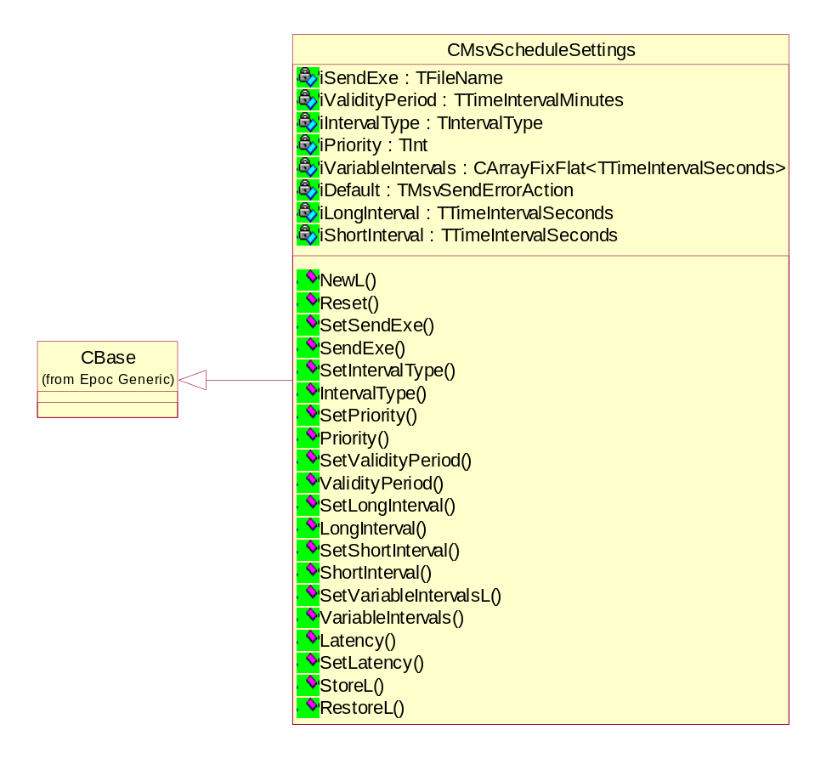

Protected Data Members
TFileName iSendExe | The .EXE that will be called by the Task Scheduler when messages are due to be sent.
TInt iPriority | The priority of the messages on the Task Scheduler. The default is KMsvDefaultSendExe.
TTimeIntervalMinutes iValidityPeriod | The time period that the messages are valid on the task scheduler. This is ignored if a message has to be sent off-peak.
TIntervalType iIntervalType | See TIntervalType declaration and Task Scheduler user documentation for a description.
TTimeIntervalSeconds iShortInterval | Used by CMsvScheduleSend::GetNextAttempt() to determine when to next send the message, if the TMsvSendErrorAction::iAction equals ERetryImmediately.
TTimeIntervalSeconds iLongInterval | Used by CMsvScheduleSend::GetNextAttempt() to determine when to next send the message, if the TMsvSendErrorAction::iAction equals ERetryLater and TMsvSendErrorAction::iRetrySpacing equals EStatic.
CArratFixFlat <TTimeIntervalSeconds> iVariableIntervals | Used by GetNextAttempt() to determine when to next send the message. If only used if TMsvSendErrorAction::iAction equals ERetryLater and TMsvSendErrorAction::iRetrySpacing equals EVariable.
TTimeIntervalSeconds iLatency | The minimum amount of time from now (the current time) that must elapse before the message is sent. Must be greater than or equal to zero (0).  If the client/UI specifies that the message should be scheduled in the past, then CMsvScheduleSend will actually schedule the message in iLatency seconds from now (the current time).

Public Enum
enum
{
EDefaultPriority = 27,
EDefaultValidityPeriod = 10080, /* 10080 Minutes in 1 week */
EDefaultIntervalType = 3, /* EYearly */
EDefaultShortInterval = 15,
EDefaultLongInterval = 180,
EDefaultLatency = 5
};

StoreL()
void StoreL(CMsvStore& aStore) const;

Description
Stores this CMsvScheduleSettings object in a stream in aStore.

Argument
CMsvStore& aStore | The CMsvStore in which to store this object.

RestoreL()
void RestoreL(CMsvStore& aStore);

Description
Restores this TMsvScheduledSettings object from a stream in aStore.

Argument
CMsvStore& aStore | The CMsvStore from which to restore this object.

Reset()
void Reset();

Description
Returns all data members to their default value, except for iVersion which is set to the value specified in schsdata.h.

SetSendExe()
void SetSendExe(const TDesC& aSendExe);

Description
iSendExe Mutator. See start of section 5 (above) for a description of iSendExe.

Argument
const TDesC& aSendExe | The value to set iSendExe to.

SendExe()
const TDesC& SendExe() const;

Description
Returns a const reference to the iSendExe member. See start of section 5 (above) for a description of iSendExe.

Returns
Const reference to iSendExe.

SetPriority()
void SetPriority(const TInt aPriority);

Description
iPriority Mutator. See start of section 5 (above) for a description of iPriority.

Arguments
const TInt aPriority | The value to set iPriority to.

Priority()
const TInt Priority() const;

Description
Returns the value of the iPriority member. See start of section 5 (above) for a description of iPriority.

Returns
Const TInt containing the value of the iPriority member.

SetValidityPeriod()
void SetValidityPeriod(const TTimeIntervalMinutes aValidityPeriod);

Description
iValidityPeriod Mutator. See start of section 5 (above) for a description of iValidityPeriod.

Arguments
const TTimeIntervalMinutes aValidityPeriod | The value to set iValidityPeriod to. Must be greater than zero (0).

ValidityPeriod()
const TTimeIntervalMinutes ValidityPeriod() const;

Description
Returns the value of the iValidityPeriod member. See start of section 5 (above) for a description of iValidityPeriod.

Returns
Const TTimeIntervalMinutes containing the value of iValidityPeriod.

SetIntervalType()
void SetIntervalType(const TIntervalType aIntervalType);

Description
iIntervalType Mutator. See start of section 5 (above) for a description of iIntervalType.

Arguments
const TIntervalType aIntervalType | The value to set iIntervalType to.

IntervalType()
const TIntervalType IntervalType() const;

Description
Returns the value of the iIntervalType member. See start of section 5 (above) for a description of iIntervalType.

Returns
Const TIntervalType containing the value of iIntervalType.

SetLongInterval()
void SetLongInterval(const TTimeIntervalSeconds& aInterval);

Description
iLongInterval mutator. See start of section 5 (above) for a description of iLongInterval.

Arguments
const TTimeIntervalSeconds& aInterval | The time interval that must elapse before re-sending a message that should be re-sent later. Must be greater than zero (0).

LongInterval()
const TTimeIntervalSeconds& LongInterval() const;

Description
Returns the value of the iLongInterval member. See start of section 5 (above) for a description of iLongInterval.

Returns
Const reference to the iLongInterval member.

SetShortInterval()
void SetShortInterval(const TTimeIntervalSeconds& aInterval);

Description
iShortInterval mutator. See start of section 5 (above) for a description of iShortInterval.

Arguments
const TTimeIntervalSeconds& aInterval | The time interval that must elapse before re-sending a message that should be re-sent immediately. Must be greater than zero (0).

ShortInterval()
const TTimeIntervalSeconds& ShortInterval() const;

Description
Returns the value of the iShortInterval member. See start of section 5 (above) for a description of iShortInterval.

Returns
Const reference to the iShortInterval member.

SetVariableIntervalsL()
void SetVariableIntervalsL(const CArrayFixFlat<TTimeIntervalSeconds>& aIntervals);

Description
iVariableIntervals mutator. See start of section 5 (above) for a description of iVariableIntervals.

Arguments
const CArrayFixFlat  <TTimeIntervalSeconds>&aIntervals | The time intervals that must elapse between each successive attempt to send a message. Each time interval must be greater than zero (0).

VariableIntervalsL()
const CArrayFixFlat<TTimeIntervalSeconds>& VariableIntervals() const;

Description
Returns a const reference to the iVariableIntervals member.

Returns
Const reference to the iVariableIntervals member. See start of section 5 (above) for a description of iVariableIntervals.

SetLatency()
void SetLatency(const TTimeIntervalSeconds& aLatency);

Description
iLatency mutator. See start of section 5 (above) for a description of iLatency.

Arguments
const TTimeIntervalSeconds& aLatency | The minimum amount of time from now (the current time) before a message may be sent. Must be greater than or equal to zero (0).

Latency()
const TTimeIntervalSeconds& Latency() const;

Description
Returns a const reference to the iLatency member. See start of section 5 (above) for a description of iLatency.

Returns
Const reference to iLatency member.

TMsvEntryScheduleData

Overview
Stores the message specific data related to scheduling.

Originally it was intended to store this data in the TMsvEntry. However it was decided not to store it in the TMsvEntry because:

- There is not enough spare space in TMsvEntry. If we changed TMsvEntry then all of the messaging would need to be re-tested.
- The data is not required by the Client/UI side.

This data will be stored in a stream associated with the TMsvEntry.

Implementation
Library | schsend.lib
DLL | schsend.dll
Header | MsvEntryScheduleData.h

Derivation
Derives from CBase.

Class Diagram
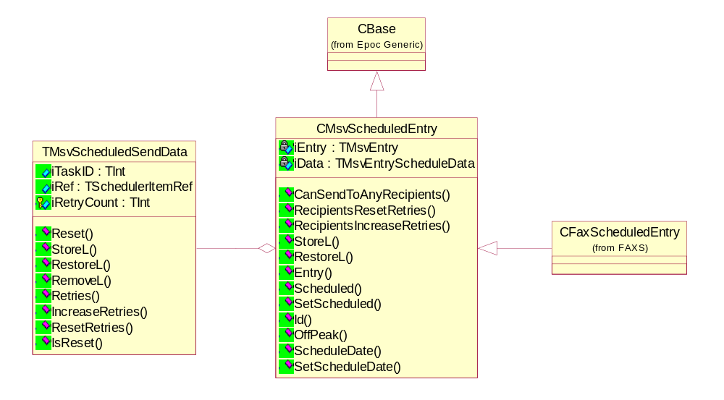

Data Members
TInt iTaskId | To store the TaskID returned by the Task Scheduler when the message is scheduled.
TSchedulerItemRef iRef | To store the TScheduledItemRef returned by the Task Scheduler when the schedule is created on which the message is scheduled.
TInt iRetryCount | To store how many retries have been made to send this message.

StoreL()
void StoreL(CMsvStore& aStore) const;

Description
To store the class in a stream of the given store.

Argument
CMsvStore& aStore | The store of the related TMsvEntry open for writing.

RestoreL()
void RestoreL(CMsvStore& aStore);

Description
To restore the class from a stream in given store.

Arguments
CMsvStore& aStore | The store of the related TMsvEntry open for reading.

RemoveL()
void RemoveL(CMsvStore& aStore) const;

Description
To remove the class’ stream in given store.

Arguments
CMsvStore& aStore | The store of the related TMsvEntry open for writing.

Reset() - Set to default
void Reset();

Description
Sets all member data to zero (0).

IsReset()
TBool IsReset() const;

Description
Returns ETrue is all the members are set to their default value, otherwise returns EFalse.

Retries()
TInt Retries() const;

Description
Returns the value of the iRetries member.

IncreaseRetries()
void IncreaseRetries();

Description
Adds one (1) to the value of the iRetries member.

ResetRetries()
void ResetRetries();

Description
Sets the iRetries member to zero (0).

TMsvOffPeakTime

Overview
There may be particular times of the day or week during which it is cheaper to make telephone calls. TMsvOffPeakTime encapsulates a single off-peak time period.

Implementation
Library | schsend.lib
DLL | schsend.dll
Header | MsvOffPeakTime.h

Class Diagram
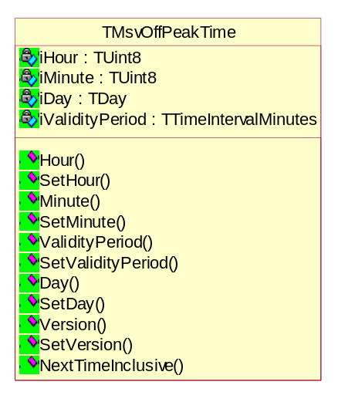

Private Data Members
TDay iDay | The day of the week when the off-peak time period starts.
TInt8 iHour | The hour of the day when the off-peak time period starts.
TInt8 iMinute | The minute of the hour when the off-peak time period starts.
TTimeIntervalMinutes iValidityPeriod | The length (in minutes) of the off-peak time period. Must be less than 24 hours.

Constructors
TMsvOffPeakTime();

TMsvOffPeakTime(const TDay aDay, const TInt aHour, const TInt aMinute, const TTimeIntervalMinutes aValidityPeriod);

Description
TMsvOffPeakTime constructors.

Arguments
const TDay aDay | The initial value of the iDay member.
const TInt aHour | The initial value of the iHour member.
const TInt aMinute | The initial value of the iMinute member.
const TTimeIntervalMinutes aValidityPeriod | The initial value of the iValidityPeriod member.

NextTimeInclusive()
const TTime NextTimeInclusive(const TTime& aFromTime) const;

Description
Returns the next time from aFromTime when this off-peak time period will become active. If aFromTime is within this off-peak time period then NextTimeInclusive() will return the start of the current off-peak time period.

Arguments
const TTime& aFromTime | See Description above.

Returns
See description above.

If aFromTime is within this off-peak time period then the return value will be less than or equal to aFromTime. Otherwise the return value will be greater than aFromTime.

The seconds and milliseconds of the return value will be set to zero (0).

ExternalizeL()
void ExternalizeL (RWriteStream&) const;

InternalizeL()
void InternalizeL (RReadStream&);

Reset()
void Reset();

Description
Returns all the member data to zero, except for iVersion which is set to the current version as specified in schsdata.h.

Day()
const TDay Day() const;

Description
Returns the value of the iDay member.

SetDay()
void SetDay(const TDay aDay);

Hour()
const TInt Hour() const;

Description
Returns the value of the iHour member.

SetHour()
void SetHour(const TInt aHour);

Description
iHour Mutator.

Arguments
const TInt aHour | The value to set iHour to. This must be in the range of 0 to 23 inclusive, otherwise SetHour() panics.

Minute()
const TInt Minute() const;

Description
Returns the value of the iMinute member.

SetMinute()
void SetMinute(const TInt aMinute);

Description
iMinute Mutator.

Arguments
const TInt aMinute | The value to set iMinute to. This must be in the range of 0 to 59 inclusive, otherwise SetMinute() panics.

ValidityPeriod()
const TTimeIntervalMinutes ValidityPeriod() const;

Description
Returns the value of the iValidityPeriod member.

SetValidityPeriod()
void SetValidityPeriod(const TTimeIntervalMinutes aValidityPeriod);

Description
iValidityPeriod Mutator.

Arguments
const TTimeIntervalMinutes aValidityPeriod | The value to set iValidityPeriod to. This must be in the range of 0 to 1440 exclusive.

CMsvOffPeakTimes

Overview
Stores an array of TMsvOffPeakTime objects, therefore represents all the off-peak time periods in each week.

CMsvOffPeakTimes is publicly inherited from CArrayFixFlat<TMsvOffPeakTime>.

Implementation
Library | schsend.lib
DLL | schsend.dll
Header | MsvOffPeakTime.h

Derivation
Derives from CArrayFixFlat<TMsvOffPeakTime>.

Class Diagram
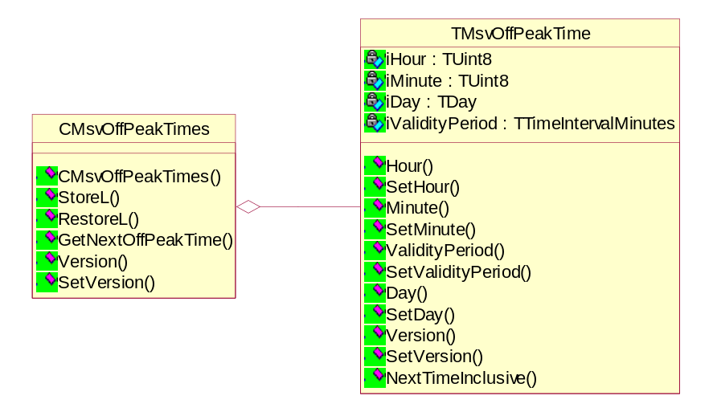

GetNextOffPeakTime()
const TInt GetNextOffPeakTime(const TTime& aFromTime, TMsvOffPeakTime& aNext, TTime& aNextTime) const;

Description
Returns the off-peak time period (TMsvOffPeakTime) that is after and closest to aFromTime. If aFromTime is within an off-peak time period, then that off-peak time period is returned.

Arguments
const TTime& aFromTime | (IN) See description above.
TMsvOffPeakTime& aNext | (OUT) The off-peak time period that is closest to aFromTime.
TTime& aNextTime | (OUT) The next start of aNext from aFromTime. See TMsvOffPeakTime::NextTimeInclusive for details.

Returns
KErrNone | No errors.
KErrNotFound | This does not contain any off-peak time periods.

Example
//Create two TMsvOffPeakTime objects (off-peak time periods)
TMsvOffPeakTime opTime1(EMonday, 20, 0, 5*60);
TMsvOffPeakTime opTime2(EWednesday, 20, 0, 5*60);

CMsvOffPeakTimes* offPeakTimes = new (ELeave) CMsvOffPeakTimes();
CleanupStack::PushL(offPeakTimes);

//Add the two off-peak time periods to offPeakTimes
offPeakTimes.AppendL(opTime1);
offPeakTimes.AppendL(opTime2);

TTime now;
now.HomeTime();

TTime nextTime;
TMsvOffPeakTime nextOffPeakTime;

//Returns the next off peak time from the current time (now)
TInt error = offPeakTimes->GetNextOffPeakTime(now, nextOffPeakTime, nextTime);

User::LeaveIfError(error);

CleanupStack::PopAndDestroy(); //offPeakTimes

StoreL()
void StoreL(CMsvStore& aStore) const;

RestoreL()
void RestoreL(CMsvStore& aStore);

TMsvSendErrorAction

Overview
An error may occur when the Server MTM is attempting to send a message or messages. If the Server MTM supports scheduling then, depending on the error or conditions, the Server MTM may want to re-schedule the message on the Task Scheduler to send at a later time.

TMsvErrorAction encapsulates the action to take for a particular error.

CMsvScheduledSend::ReScheduleL() (in combination with CMsvSendErrorActions) will use the TMsvSendErrorAction to determine whether to re-schedule the message.

Implementation
Library | schsend.lib
DLL | schsend.dll
Header | MsvSendErrorAction.h

Class Diagram
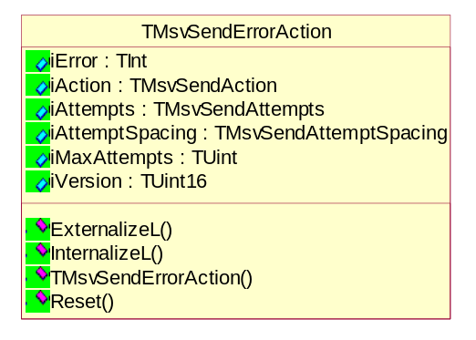

Public Enums

TMsvSendAction
enum TMsvSendAction
{
EFail,
ERetryImmediately,
ERetryLater
};
Used to determine whether to re-schedule the message.

TMsvSendRetries
enum TMsvSendRetries
{
EFixed,
EInfinite
};
Used to determine how many attempts should be made to send the message.

TMsvSendRetrySpacing
enum TMsvSendRetrySpacing
{
EStatic,
EVariable
};
Used to determine the spacing between attempts to send the message.

Public Data Members
TInt iError | The error.
TMsvSendAction iAction | The action to take if this error occurs.
TMsvSendRetries iRetries | The number of attempts to make at sending a message if this error occurs. If iRetries equals EInfinite then sending will be attempted until successful (or the user intervenes). This member is ignored if iAction equals EFail.
TMsvSendRetrySpacing iRetrySpacing | This member will be used by CMsvSendErrorActions to determine when to re send the message. This member is ignored if iAction equals EFail.
TInt iMaxRetries | The maximum number of times to attempt to send a message if this error occurs. This member is ignored if iAction equals EFail or iRetries equals EInfinite.

CMsvSendErrorActions

Overview
This class determines what action to take if an error occurs while the Server MTM is sending a message (or messages).

It encapsulates an array of TMsvSendErrorAction objects, which it uses to determine the action to take for a particular error. If the error is not found in the array then CMsvSendErrorAction uses its default TMsvSendErrorAction object.

Implementation
Library | schsend.lib
DLL | schsend.dll
Header | MsvSendErrorAction.h

Class Diagram
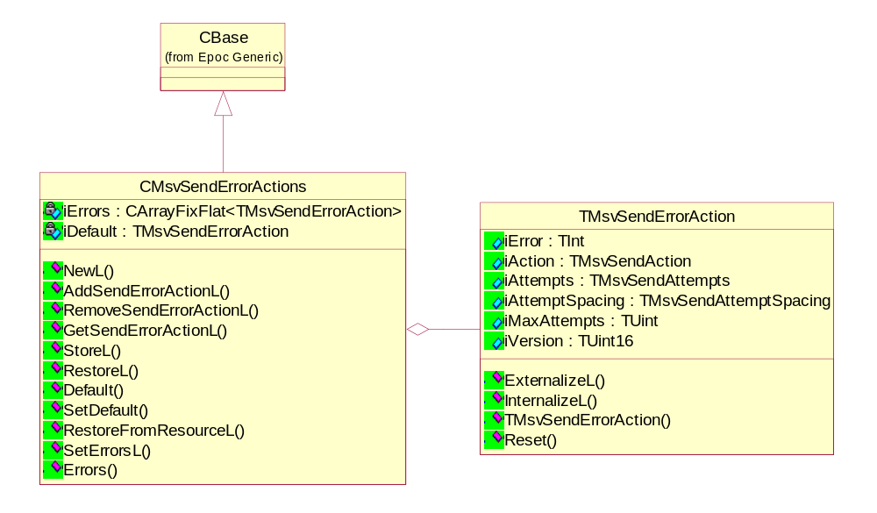

Private Data Members
CArrayFixFlat <TMsvSendErrorAction>* iErrors | The array of TMsvSendErrorAction objects.
TMsvSendErrorAction iDefault | The default TMsvSendErrorAction object, which may be used if the error is not found in iErrors.

NewL()
static CMsvSendErrorActions* NewL();

Description
CMsvSendErrorActions factory function:
- Creates a new CMsvSendErrorActions object;
- Calls the private ConstructL function; and
- Returns the new object.

Arguments
const CMsvSendErrorActions& aActions | aActions will be copied into the new CMsvSendErrorActions object.

AddSendErrorActionL()
void AddSendErrorActionL(const TMsvSendErrorAction& aErrorAction);

Description
Adds a TMsvSendErrorAction object (aErrorAction) to iErrors. If a TMsvSendErrorAction already exists in iErrors for the same error then it is replaced by aErrorAction.

Arguments
const TMsvSendErrorAction& aErrorAction | The TMsvSendErrorAction to add to the iErrors member.

RemoveSendErrorAction()
const TInt RemoveSendErrorAction(const TInt aError);

Description
Removes the TMsvSendErrorAction from iErrors for the error aError.

Arguments
const TInt aError | The error condition to remove from iErrors.

Returns
KErrNone | If successful.
KErrNotFound | If cannot locate a TMsvSendErrorAction in iErrors that for aError.

GetSendErrorAction()
const TInt GetSendErrorAction(const TInt aError, TMsvSendErrorAction& aErrorAction) const;

Description
Finds the TMsvSendErrorAction in iErrors which corresponds to the error aError.

Arguments
const TInt aError | (IN) The error condition to retrieve from iErrors.
TMsvSendErrorAction& aErrorAction | (OUT) The TMsvSendErrorAction in iErrors which corresonds to the error aError.  Will be unchanged if GetSendErrorAction() returns KErrNotFound.

Returns
KErrNone | If successful.
KErrNotFound | If cannot locate a TMsvSendErrorAction in iErrors that for aError.

StoreL()
void StoreL(CMsvStore& aStore) const;

Description
Stores iErrors and iDefault in a stream of aStore.

RestoreL()
void RestoreL(CMsvStore& aStore);

Description
Restores iErrors and iDefault from a stream of aStore.

RestoreFromResourceL()
void RestoreFromResourceL(TResourceReader& aReader);

Description
Restores this from a resource. The resource must be of type SEND_ERROR_ACTIONS, as specified in schsend.rh.

SetDefault()
void SetDefault (const TMsvSendErrorAction& aErrorAction);

Description
Sets iDefault to aErrorAction.

Default()
const TMsvSendErrorAction& Default() const;

Description
Returns a const reference to the iDefault member.

CMsvScheduledEntry

Overview
Abstract base class which stores the schedule data and recipients of a message. It has three (3) pure virtual functions that must be implemented by the Server MTM:
- CanSendToAnyRecipients();
- RecipientsResetRetries(); and
- RecipientsIncreaseRetries().

Use the Fax Server MTM examples to see how to implement the pure virtual functions.

CMsvScheduledEntry does not force the Server MTM to store the message recipients in a certain way. However, it is recommended that the Server MTM derive its recipients class from CMsvRecipient, because the class already has support for the number of retries to send a message to a recipient.

CMsvScheduledEntry stores the TMsvEntry to which it relates in order to provide quick access to the scheduling related members of the TMsvEntry without having to call CMsvServerEntry::SetEntry() every time. However CMsvScheduledEntry does not provide access to all the members of the TMsvEntry. This is to stop the user of the CMsvScheduledEntry from accessing the descriptor members of the TMsvEntry while the server entry is not set to the TMsvEntry.

Implementation
Library | schsend.lib
DLL | schsend.dll
Header | MsvScheduledEntry.h

Class Diagram
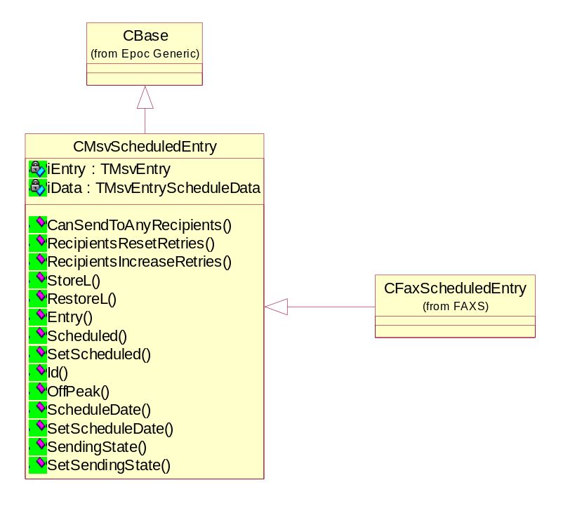

Data Members
TMsvEntry iEntry | The TMsvEntry to which the CMsvScheduledEntry related. Passed into CMsvScheduledEntry at construction time. Its members can only be accessed and modified through the public functions of CMsvScheduledEntry.
TMsvEntryScheduleData iData | The schedule specific data of the message.

CanSendToAnyRecipients()
TBool CanSendToAnyRecipients(const TMsvSendErrorAction& aAction) = 0;

TBool CanSendToAnyRecipients(const CMsvSendErrorActions& aErrorActions, TMsvSendErrorAction& rAction) = 0;

Description
Determines whether any (at least one) of the recipients of this message can still be sent to.

This is a pure virtual function, which must be implemented by the Server MTM.

Called by CMsvScheduledSend::SetMessageStartTime().

Arguments (v1)
const TMsvSendErrorAction& aAction | (IN) The TMsvSendErrorAction object that was passed into CMsvScheduleSend::ReScheduleL(). This object represents how the client would like this message re-scheduled.

Arguments (v2)
const TMsvSendErrorActions& aErrorActions | (IN) The TMsvSendErrorActions object stored of the Server MTM that is attempting to re-schedule the message.
TMsvSendErrorAction& rAction | (OUT) If CanSendToAnyReceipients() returns ETrue, then rActions will contain the action to take when re-scheduling the message. CanSendToAnyRecipients() should determine rActions by calling aErrorActions.GetSendErrorAction() with the error code of the associated TMsvEntry or an error code stored against any of the recipients.

Returns
ETrue | At lease one of the recipients has not been sent the message.
EFalse | None of the recipients should be sent the message.

Fax Implementation (as at 31/5/2000)
TBool CFaxScheduledEntry::CanSendToAnyRecipients(const TMsvSendErrorAction& aAction)
{
TInt count = iHeader->Count();
TBool retVal = EFalse;

while (count--)
{
CFaxRecipient* rcpt = iHeader->At(count);

retVal |= CheckRecipient(*rcpt, aAction);
}

return retVal;
}

TBool CFaxScheduledEntry::CanSendToAnyRecipients(const CMsvSendErrorActions& aErrorActions, TMsvSendErrorAction& aAction)
/*
Returns ETrue if can still send to any of the recipients
of this message.
Otherwise returns EFalse.
*/
{
TInt count = iHeader->Count();
TBool retVal = EFalse;

while (count--)
{
CFaxRecipient* rcpt = iHeader->At(count);

TMsvSendErrorAction action;

if (aErrorActions.GetSendErrorAction(rcpt->Error(), action) != KErrNone)
{
action = aErrorActions.Default();
}

if (CheckRecipient(*rcpt, action))
{
retVal = ETrue;
aAction = action;
}
}

return retVal;
}

TBool CFaxScheduledEntry::CheckRecipient(CFaxRecipient& aRcpt, const TMsvSendErrorAction& aAction)
{
TBool retVal = EFalse;

if (aRcpt.Status() != CMsvRecipient::ESentSuccessfully)
{
if (aAction.iAction == ESendActionSentAlready)
{
aRcpt.SetStatus(CMsvRecipient::ESentSuccessfully);
}
else if (aAction.iAction == ESendActionFail)
{
aRcpt.SetStatus(CMsvRecipient::EFailedToSend);
}
else if (aAction.iRetries == ESendRetriesInfinite || aRcpt.Retries() < aAction.MaxRetries())
{
aRcpt.SetStatus(CMsvRecipient::ENotYetSent);
retVal = ETrue;
}
else
{
aRcpt.SetStatus(CMsvRecipient::EFailedToSend);
}
}

return retVal;
}

SMS Implementation (as at 31/5/2000)
TBool CSmsScheduledEntry::CanSendToAnyRecipients(const TMsvSendErrorAction& aAction)
{
CArrayPtrFlat<CSmsNumber>& numbers = iHeader->Recipients();
TInt count = numbers.Count();

TBool retVal = EFalse;

while (count--)
{
CSmsNumber* rcpt = numbers[count];

retVal |= CheckRecipient(*rcpt, aAction);
}

return retVal;
}

TBool CSmsScheduledEntry::CanSendToAnyRecipients(const CMsvSendErrorActions& aErrorActions, TMsvSendErrorAction& aAction)
/*
Returns ETrue if can still send to any of the recipients
of this message.
Otherwise returns EFalse.
*/
{
CArrayPtrFlat<CSmsNumber>& numbers = iHeader->Recipients();
TInt count = numbers.Count();

TBool retVal = EFalse;

while (count--)
{
CSmsNumber* rcpt = numbers[count];

TMsvSendErrorAction action;

if (aErrorActions.GetSendErrorAction(rcpt->Error(), action) != KErrNone)
{
action = aErrorActions.Default();
}

if (CheckRecipient(*rcpt, action))
{
retVal = ETrue;
aAction = action;
}
}

return retVal;
}

TBool CSmsScheduledEntry::CheckRecipient(CSmsNumber& aRcpt, const TMsvSendErrorAction& aAction)
{
TBool retVal = EFalse;

if (aRcpt.Status() != CMsvRecipient::ESentSuccessfully)
{
if (aAction.iAction == ESendActionSentAlready)
{
aRcpt.SetStatus(CMsvRecipient::ESentSuccessfully);
}
else if (aAction.iAction == ESendActionFail)
{
aRcpt.SetStatus(CMsvRecipient::EFailedToSend);
}
else if (aAction.iRetries == ESendRetriesInfinite || aRcpt.Retries() < aAction.MaxRetries())
{
aRcpt.SetStatus(CMsvRecipient::ENotYetSent);
retVal = ETrue;
}
else
{
aRcpt.SetStatus(CMsvRecipient::EFailedToSend);
}
}

return retVal;
}

RecipientsResetRetries()
virtual void RecipientsResetRetries() = 0;

Description
Sets all the recipients’ retries to zero (0). This is a pure virtual function, which must be implemented by the Server MTM.

Fax Implementation (as at 17/11/1999)
void CFaxScheduledEntry::RecipientsResetRetries()
{
TInt count = iFaxHeader->Count();

while (count--)
{
CFaxRecipient* rcpt = iFaxHeader->At(count);

if (rcpt->Status() != CMsvRecipient::ESentSuccessfully)
{
rcpt->ResetRetries();
}
}
}

RecipientsIncreaseRetries()
virtual void RecipientsIncreaseRetries() = 0;

Description
Increases all the recipients’ retries by one (1). This is a pure virtual function, which must be implemented by the Server MTM.

Fax Implementation (as at 17/11/1999)
void CFaxScheduledEntry::RecipientsIncreaseRetries()
{
TInt count = iFaxHeader->Count();

while (count--)
{
CFaxRecipient* rcpt = iFaxHeader->At(count);

if (rcpt->Status() != CMsvRecipient::ESentSuccessfully)
{
rcpt->IncreaseRetries();
}
}
}

Entry()
void Entry(TMsvEntry& aEntry);

Description
Sets the iDate, Scheduled and SendingState members of aEntry to the values stored in iEntry.

Entry() is called several times by CMsvScheduledSend just before a CMsvServerEntry::ChangeEntry() is performed on aEntry.

Arguments
TMsvEntry& aEntry | The message who’s iDate, Scheduled and SendingState members needs updating.

Implementation (as at 17/11/1999)
void CMsvScheduledEntry::Entry(TMsvEntry& aEntry)
{
aEntry.iDate = iEntry.iDate;
aEntry.SetScheduled(iEntry.Scheduled());
aEntry.SetSendingState(iEntry.SendingState());
}

SCHEXE.EXE

Overview
When the time has elapsed for a task on the Task Scheduler, the task scheduler calls a .EXE program with a list of TaskIDs.

SCHEXE.EXE has been implemented which receives notification from the Task Scheduler that messages need to be sent.

SCHEXE.EXE
- Receives an array of Tasks from the Task Scheduler.
- Unpackages the data stored in each task. The data contains the Command ID and Parameter to pass to TransferCommandL(), and the message ID.
- Creates a CMsvEntrySelection of messages that need to be sent.
- Calls CMsvSession::TransferCommandL() with the selection of messages, the

